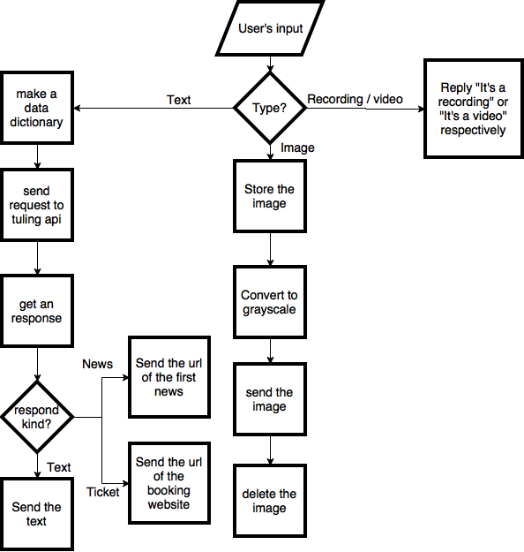Flowchart:

Instruction:

Talk to the bot just like you would chat with a human, it can be fun. If you need information about the news, the airlines, or the trains, you can ask the bot as well. It will automatically reply you with the link to an informatics website where you can read the news/ book your ticket as you wish. If you send an image to the bot, it will convert it to grayscale and send it back to you. Have fun!